Monitoring the Climate Crisis Hands-On

With so much science behind the fight against climate change and global warming, we wanted to get a chance to cut through the noise and take a look ourselves. There are so many rich data sources online and they are FREE, which is fantastic news for the SMU student on a budget. We have decided to follow 5 different metrics that may show us the trends that may give us an understand of how the climate, specifically within the continental United States, has shifted over the past decades. We will be looking at historical data pertaining to:

* Temperature and Precipitation
  + <https://www.ncei.noaa.gov/data/global-summary-of-the-day/archive/>
* Greenhouse Gas Volume
  + <https://www.esrl.noaa.gov/gmd/dv/data/index.php?category=Greenhouse%2BGases&frequency=Monthly%2BAverages&site=BRW&type=Flask>
* Solar Radiation

* + <ftp://ftp.ncdc.noaa.gov/pub/data/nsrdb-solar/>
* Frequency and danger of Severe Weather
  + <https://www.ncdc.noaa.gov/stormevents/ftp.jsp>
* Flow Rate and Gage Height of Rivers and Lakes in Texas
  + <https://waterdata.usgs.gov/nwis/sw>
* Oceanic Sea Surface Temperatures
  + <https://www.epa.gov/climate-indicators/climate-change-indicators-sea-surface-temperature>

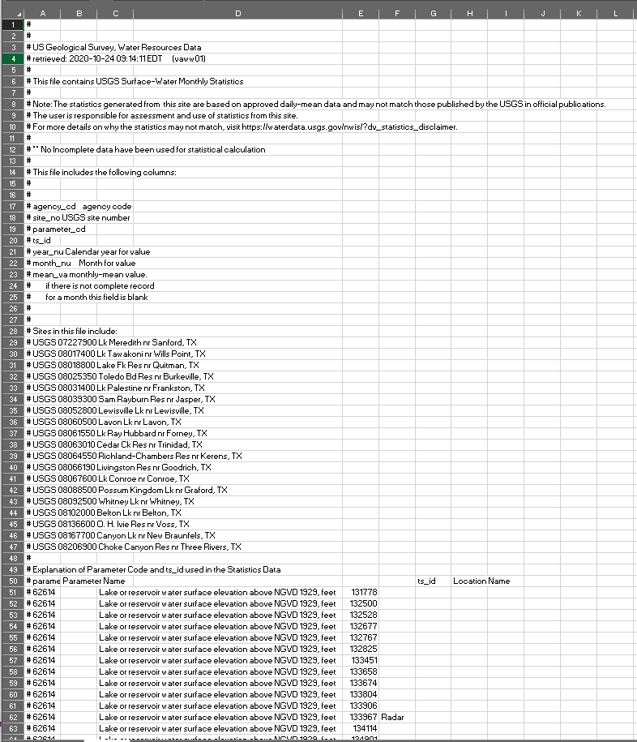

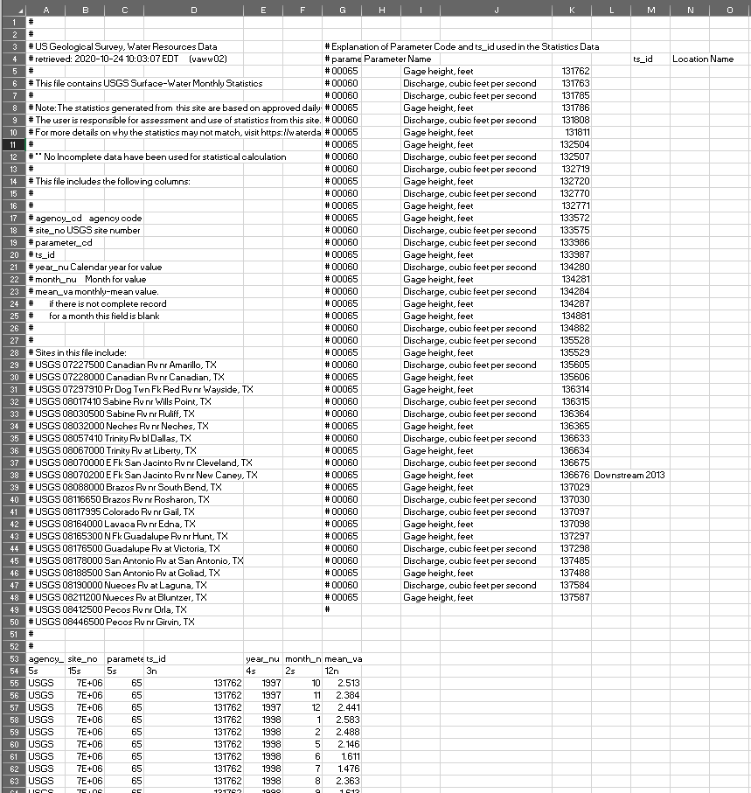

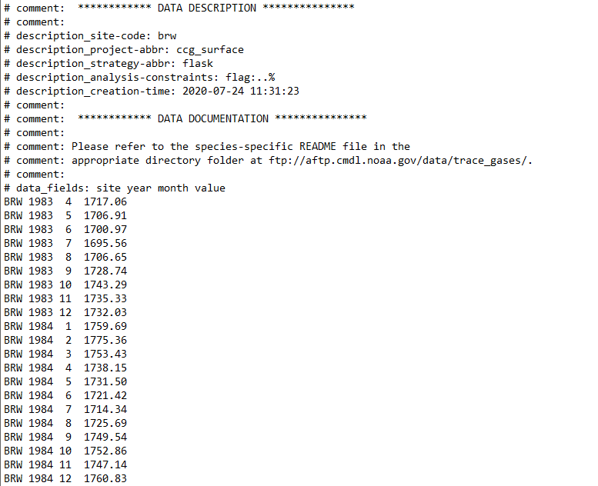

Sea Surface Variance Chart

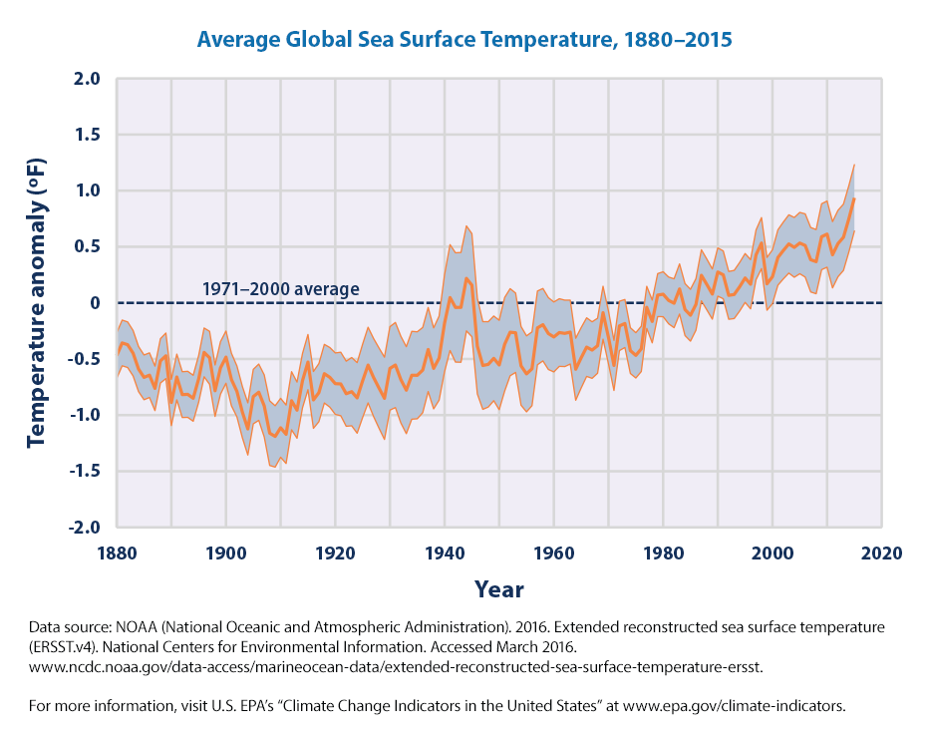

Sea Surface Variance Map

